GATTAMOLESTA
( Gitan Punk – Romagna, Italy )
*since 2005*
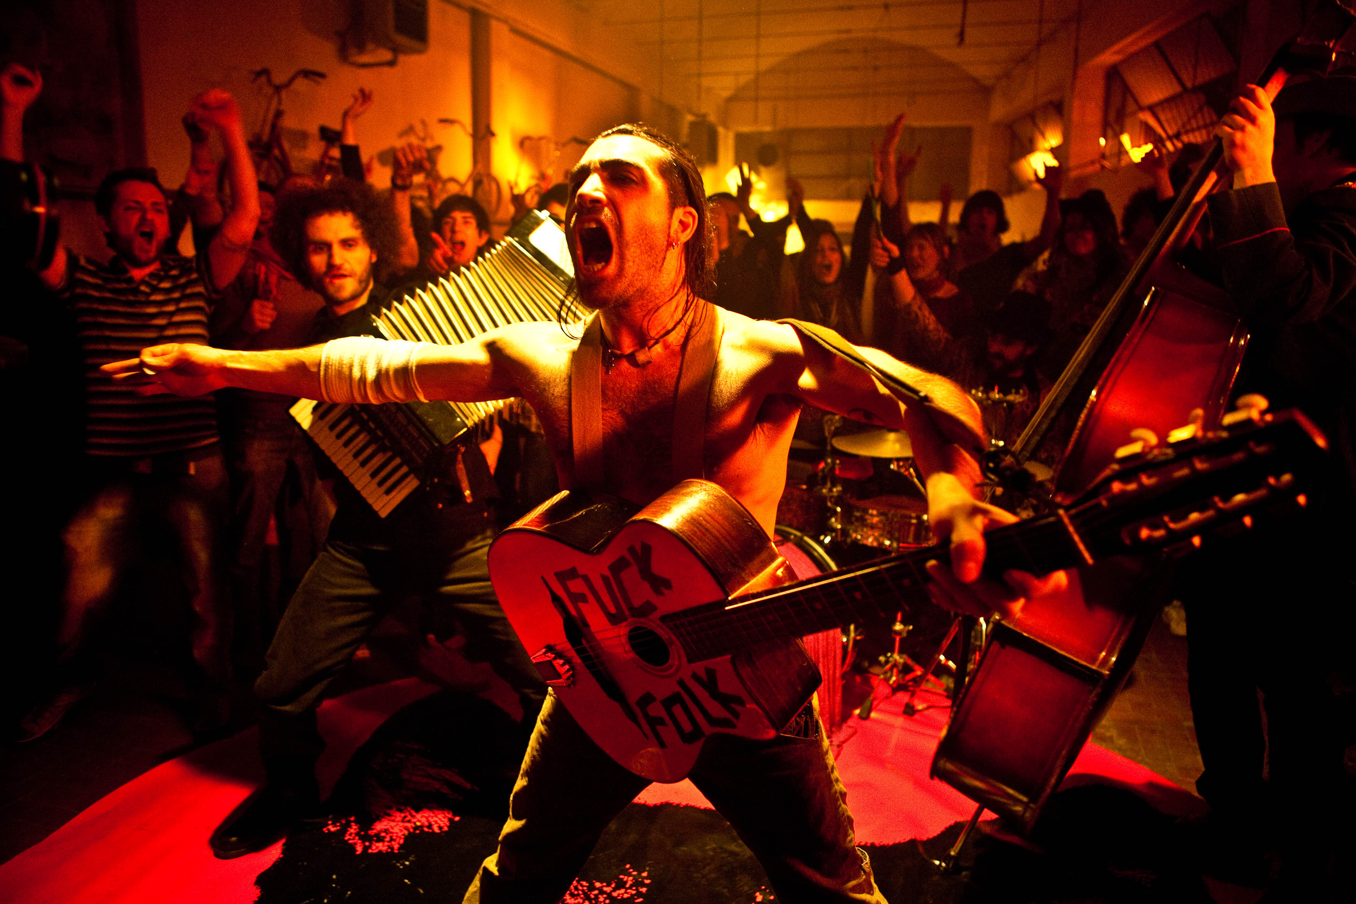

Short Bio:
They back on the road proposing their very first setlist that set fire the stages of half of Europe!
From Azzorre Islands to Ukraine, acrossing 15 nations, with their amazing Gipsy, Balkan, Gitan Punk show, they became one of most popular italian bands abroad.
The charismatic singer Andrea Gatta lead the stage among world music, flamenco guitars, mariachi trumpets and the contagious balkanic charme.

Line Up:
Andrea GATTA “Molesta”: Voce, Chitarra Acustica
Nik “Moustace” Fiori: Contrabbasso
Luigi “Klider” Flocco: Fisarmonica, tastiere, cori
Andrea “Katrame” Cordella: Tromba, tastiere, cori
Mattia “Burio” Burioli: Batteria
Nicolò “Nik” Salvatori: Chitarra Elettrica

Official Videoclips:
• GATTAMOLESTA” : https://youtu.be/Gh5VdLe3jI8
• AMORE PECHINESE : https://youtu.be/rOoQ4sVilnY
• Il CUOR DI BELZEBU’ : https://youtu.be/-HcWcHhtz0c
• OTTO ORANGUTAN: https://youtu.be/_WvDT-AJdPA
• YOU SPIN ME ROUND (Barbecue Version) : https://youtu.be/qwO66Y3kogY
• AVREI POTUTO : https://youtu.be/bw8mAmUu0VQ

Web Contacts:
Web site: http://www.gattamolesta.it
Facebook: https://www.facebook.com/GATTAMOLESTA/
Instagram: https://www.instagram.com/gattamolestaband/
YouTube: https://www.youtube.com/user/bandgattamolesta/
Spotify: https://open.spotify.com/artist/7KzqF3z1cvnQw2Z55L1BWo

Discography:
2012 – CD @ Vecchio Mondo (Felmay)
2009 – CD @ Czeleste (Felmay)
2009 – EP @ I pesci, i pani e gli esemplari (Felmay)
2008 – CD @ Alla Festa del Brigante

