LENNON KELLY
( Irish Punk Folk - Romagna, Italy )
*since 2011*
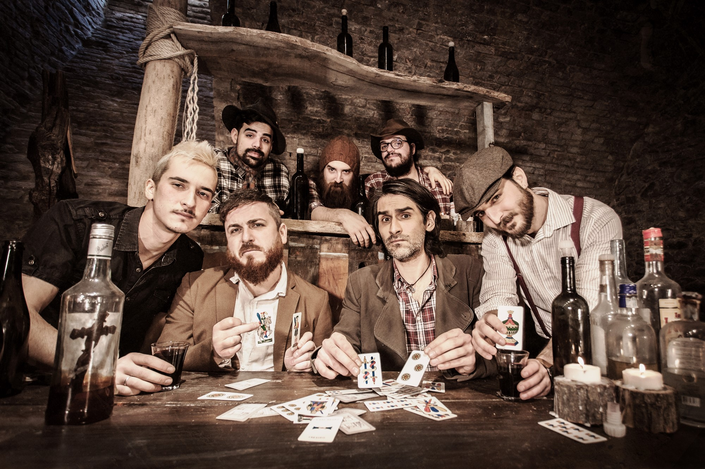

Short Bio:
From Romagna's hills this young band unites his own Punk-Rock attitude with the Irish Folk sounds of Violin, Pipe and Banjo.
In 2014 they perform at Rock In Idro, as the only Italian band, opening to The Pogues, Ska-P, Gogol Bordello, Millencolin, Pennywise, Russkaja, Snuff..
In 2016 they played in Hamburg for celebration of the 10 years of twinning of supporters of St Pauli and Celtic Glasgow.
In 2017 for the first time they share the stage with Flogging Molly.
In 2018 the 3rd album "Malanotte" is released by IndieBox/Self.

In 2021 they were awarded as the “best Italian Celtic Punk band” on the Musica Celtica Music Awards.

Line Up:
Vasco BARTOWSKI Abbondanza: Lead Vocals, Acoustic Guitar
Costantino ROMAN Valentini: Lead Vocals, Lead Electric Guitar, Banjo, Mandolin
Alessandro POBRE Valentini: Bass Guitar
Mattia AGO Agozzino: Electric Guitar, Banjo, Mandolino, Backing Vocals
Mirco CIRCO Turci: Violin, BagPipe, Tin Whistle, Backing Vocals
Enrico PERRY Ricci: Accordion
Davide DAVINO Paci: Drums

Official Videoclips:
Dove vanno a finire le bestemmie? : https://youtu.be/-_4Ejwec_lw?si=l4STztctOsy_t_T8
Il passatore : https://youtu.be/-2PxYheF4Xk?si=9jo--md-xylAfSmF
Il ballo dell’ultima ora : https://youtu.be/qSKkL2wQzAw
Se questa è terra : https://youtu.be/r_k1YokVXY0
Surival : https://youtu.be/SwSk1Z6txJw
Mio fratello feat. Punkreas : https://youtu.be/IfPUGF_Bv_M
“Live at Montelago Celtic Festival @ Serravalle di Chienti (Italy)” : https://youtu.be/EaM-BburLMc
Mazapègul : https://youtu.be/9PUPFugXC3c
La malanotte : https://youtu.be/n6pY5FR-Wj4
Sangue e sale : https://youtu.be/q2BnlH9y6fw
Galway girl : https://youtu.be/jcvFHMpxDwE
Motivo per restare : https://youtu.be/A0518SAwy_0

Web Contacts:
Web site: https://lennonkelly.com
Facebook: https://facebook.com/lennonkelly23/
Instagram: http://instagram.com/lennonkelly.official
YouTube: https://youtube.com/TheLennonKelly
Spotify: https://open.spotify.com/artist/0R8DdGb0eyfPe1nMvGEXZO

Discography:
2018 – CD @ Malanotte (Indie Box Records/Self)
2015 – CD @ Lunga Vita al Re (Indie Box Records/Self)
2012 – EP @ Lennon Kelly (Indie Box Records/Self)

