NUJU
( Turbo Folk - Emilia )
*since 2009*
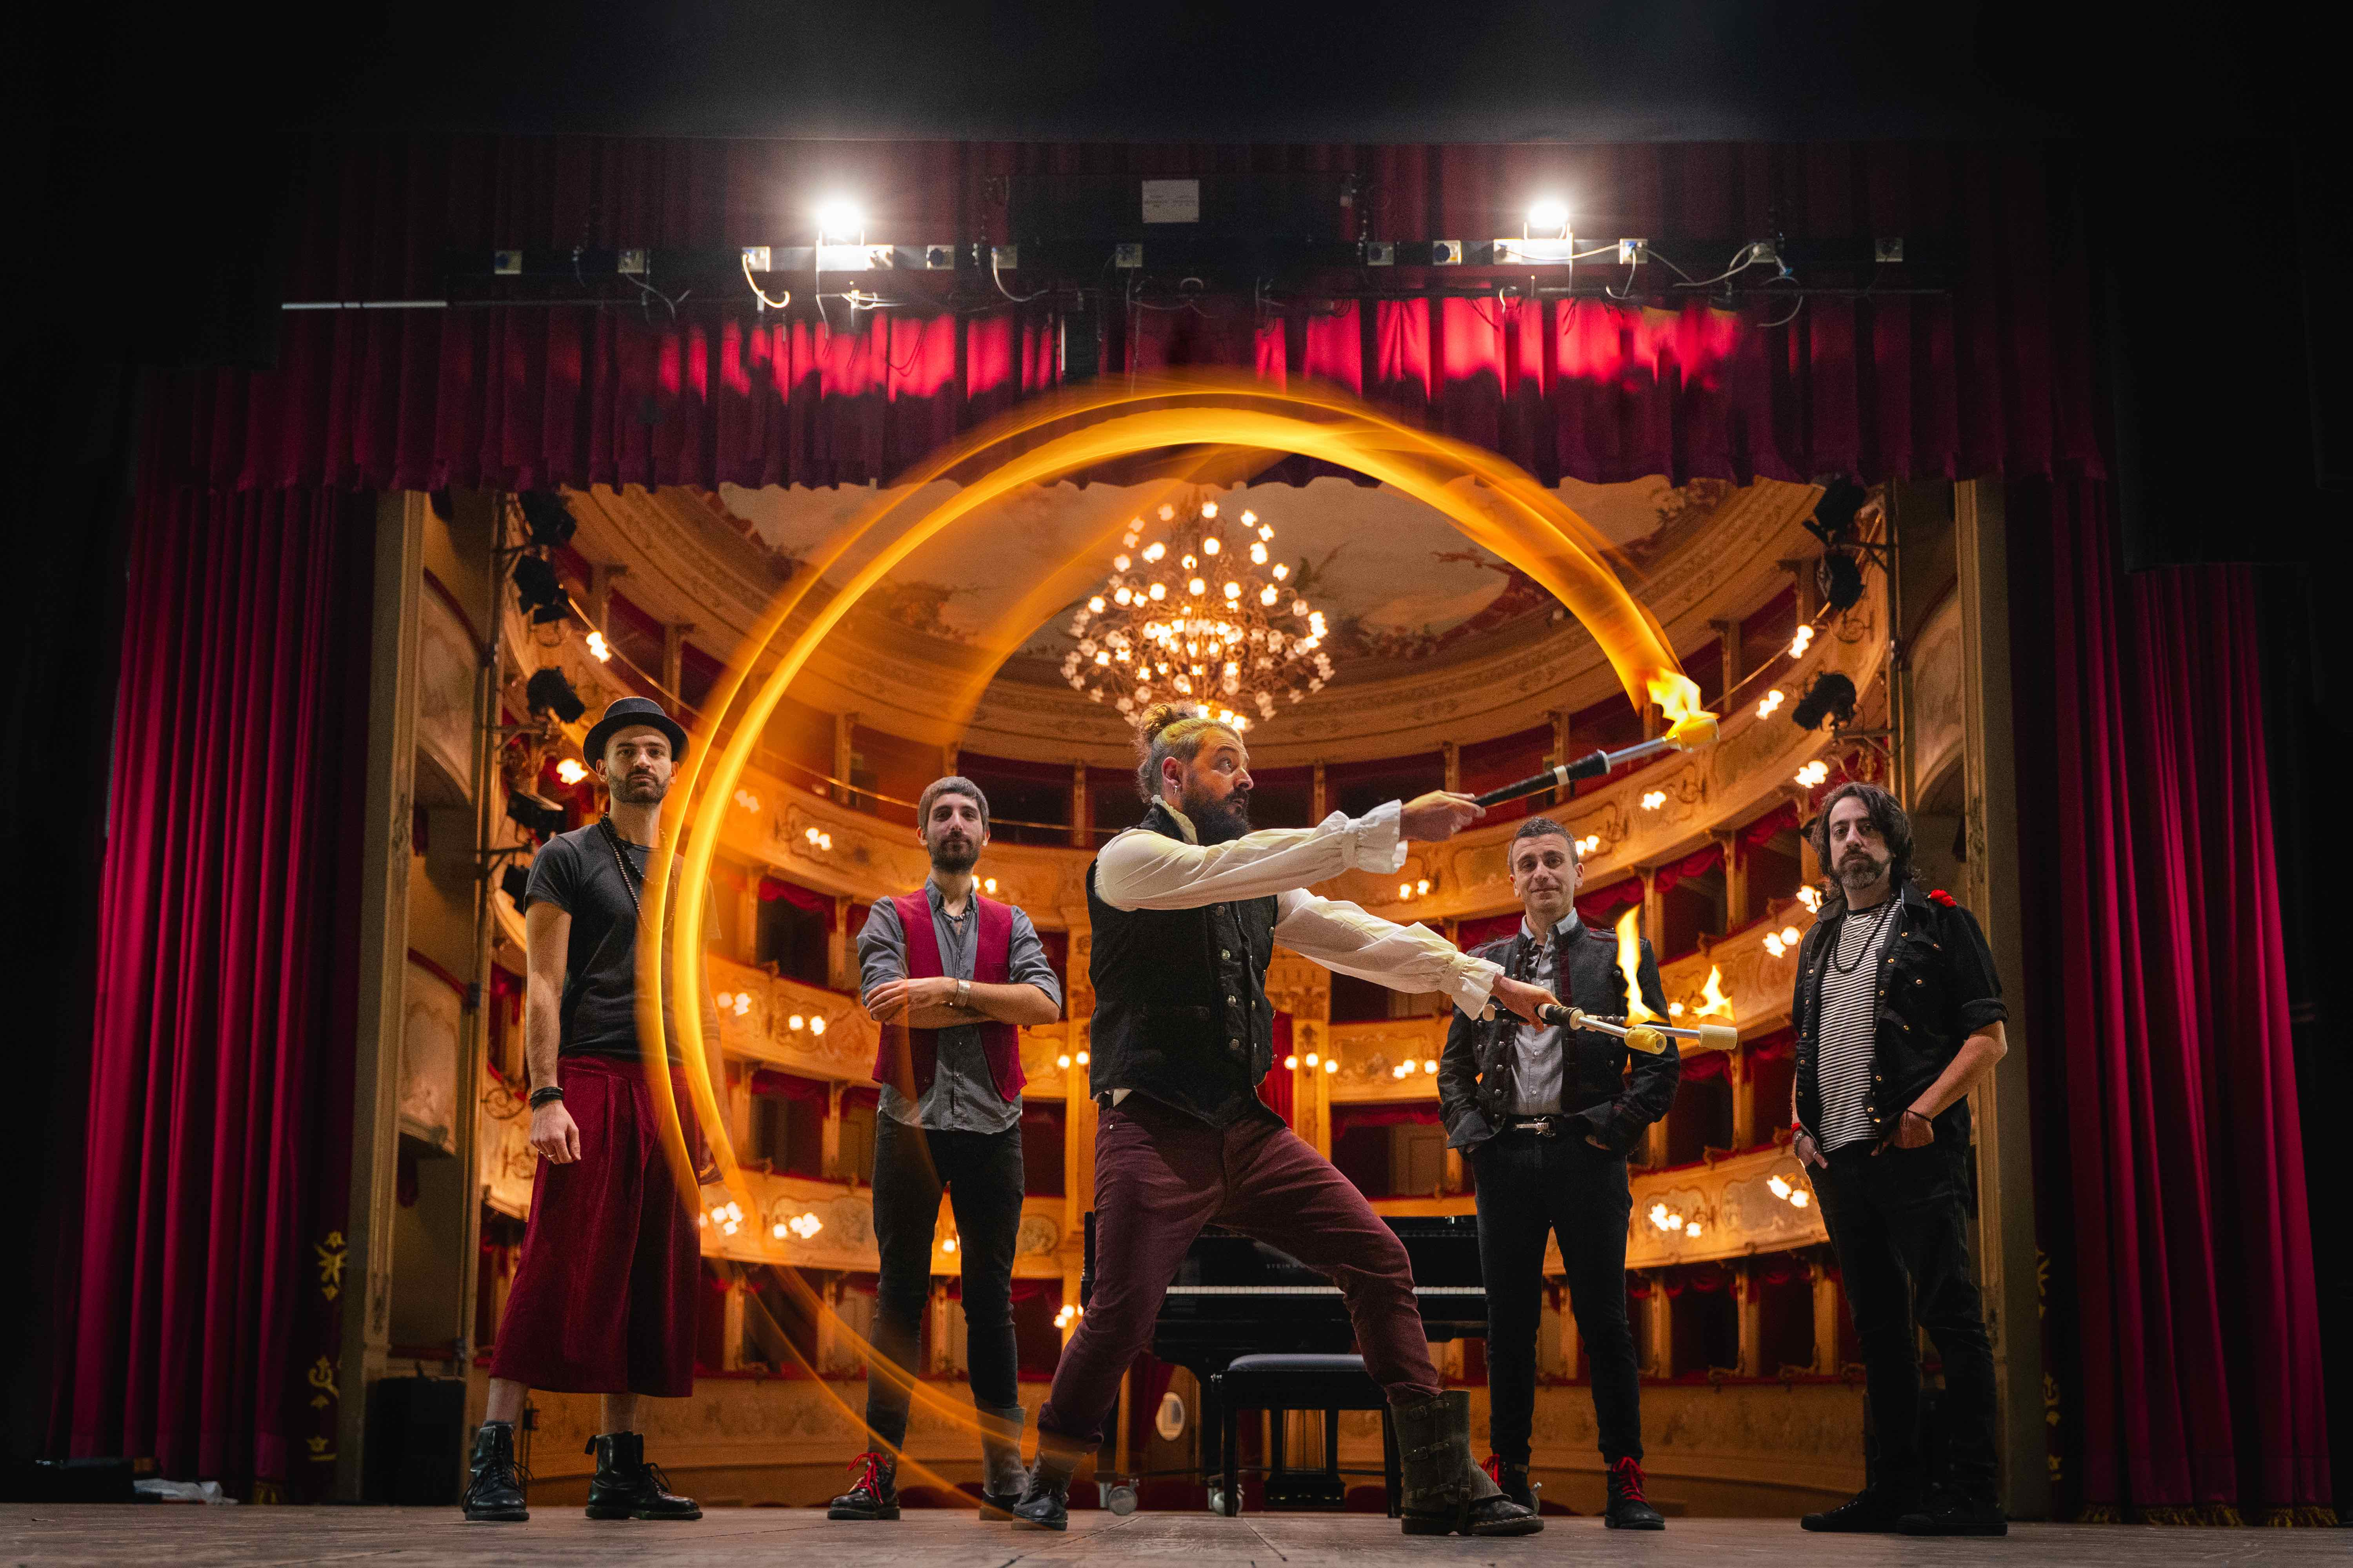
Short Bio:
Band was founded with the desire to unite the authorial Folk to Italian Dance to create pure fun!
Band has always been careful to strong social issues by combining valuable content to music always cheerful and engaging.
During years they played hundreds concerts in Italy and Germany (the singer was born in Germany!).
To remember the performances at the big event Ligabue Campovolo 2.0 and some opening act to Manu Chao.
In 2022 the 7th album "Clessidra" is released by Manita Dischi/Audioglobe.
​

Line Up:
Fabrizio Cariati: Voice, synth and theremin
Marco Ambrosi: Guitar
Lorenzo Iori: Violin, synth, mandolino
Nicholas De Francesco: Guitar bass
Davide Ferretti: Drums

Official Videoclips:
Gira feat. Modena City Ramblers: https://youtu.be/FxkcIC5WOjA
Titoli di Coda: https://youtu.be/nf4aTW6aqVs
La Nostra Sicurezza: https://youtu.be/WZGlTnAgH2M
Onde Radio feat. Apres La Classe: https://youtu.be/YzmALSZOGHA
Ferro e Ruggine: https://youtu.be/Xl268Eb5AnU
Gluck “Hungary Tour”: https://youtu.be/4XpV7Z7EJaw
Una Faccia una Razza: https://youtu.be/ya7gQ4SjUUI
Denaro: https://youtu.be/q0fMGBH5Mj8
L’Artista feat. Modena City Ramblers: https://youtu.be/mDR2AnSfe6o
Menestrello: https://youtu.be/_hDiE2VgEro
Movement: https://youtu.be/chFEIjfOl1U
Convinto: https://youtu.be/hSb7jRlCQlU
Zingara: https://youtu.be/GPAVtBuFupk
La Rapina: https://youtu.be/I-HPsAPBXdA
Parto: https://youtu.be/HMG4HXWRYwI
Voci di Marinai: https://youtu.be/8T-MuzJZIfg
Disegnerò: https://youtu.be/rUJ1RU1JJRM
Mi sono perso: https://youtu.be/iDhhcTdm6J4
Il Furgone: https://youtu.be/YvI8Ex7E_ro

Web Contacts:
Web Site: http://www.nuju.it
Facebook: https://www.facebook.com/nujuband
Instagram: https://www.instagram.com/nujuband
YouTube: https://www.youtube.com/nujuband
Spotify: https://open.spotify.com/artist/5wWvJjnWyhXdWmEVffAONX
Wikipedia: https://it.wikipedia.org/wiki/Nuju

Discography:
2022 – CD @ Clessidra (Manita Dischi/Audioglobe)
2018 – CD @ Storie Vere di una Nave Fantasma (Manita Dischi/Audioglobe)
2016 – CD @ Pirati e Pagliacci (Latlantide/Edel)
2015 – CD @ Urban Box (MK Records)
2012 – CD @ 3° (mondo) (MK Records)
2011 – CD @ Ghost Tricks (autoproduzione limitata per 100 fan)
2011 – CD @ Atto Secondo (MK Records – Volta la Carta)
2010 – CD @ Nuju (Latlantide)

