RISERVA MOAC
( World,Patchanka - Molise, Italy )
*since 2003*
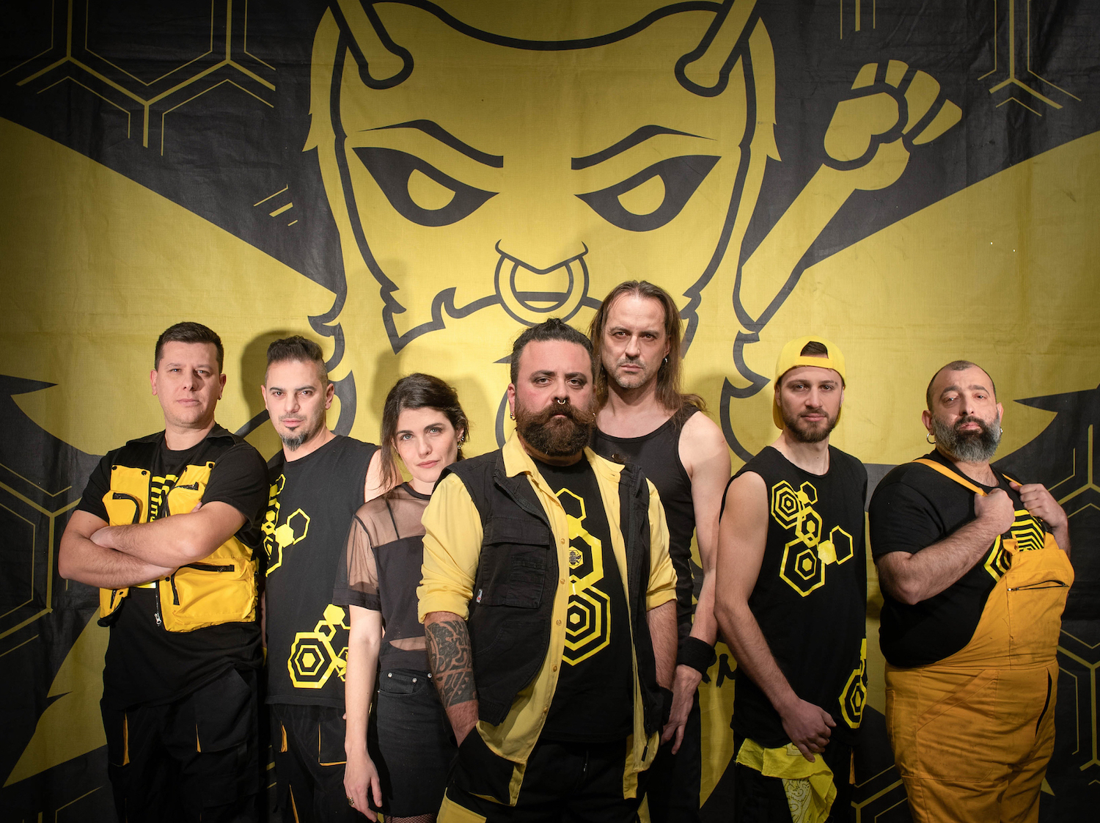
Short Bio:
A no border band..
Sounds, words and rhythms from all over the world give rise to their distinctive and personal sound that goes from World to Balkan to Irish to Patchanka music.

Many performances around Italy and Europe (France, Switzerland, Netherland, Germany, Austria) until to arrive to a tour across USA;
among their many live concerts we remember Arezzo Wave and Primo Maggio in Piazza San Giovanni (Rome).

In 2014 band wins the HitMusicAwards competition getting the pubblication of two songs in the famous Hit Mania compilation.

In 2019 the 4th album "Tintilia Gran Riserva" was released by Escudero Records/Disques Office, currently the band is working on new recording album.

​
Line Up:
Pacha Mama : Voice
Eva: Voice
Roberto Napoletano : Accordion
Patrizio Forte : Bass Guitar
Fabio Castrilli : Guitar
Graziano Carbone : Drums
Antonio Scioli : Tuba, BagPipe, Flutes

Official Videoclips:
Ballo di Frontiera: https://youtu.be/44DXBWHKQdU
Tintilia Gran Riserva : https://youtu.be/MvXbx6M6-sQ
Beltane : https://youtu.be/ZO0vu9GQL1k
Alcolizzato Sentimentale : https://youtu.be/58QuCm67sJ0
Balkoscenico : https://youtu.be/wFaz9SR8ecc
Babilonia : https://youtu.be/GPThvouQ28Q
La Musica dei Popoli : https://youtu.be/ljOM8djwSjU
Mayday Midai : https://youtu.be/1wRdSJfjalM
Live @ Montelago Celtic Festival (Altopiano di Colfiorito, PG) - https://youtu.be/IplJ0ld-1vg
Live @ TFF Festival (Rudolstadt, Germania) - https://youtu.be/aZTHMQDehD4

Web Contacts:
Web Site: http://www.riservamoac.com
Facebook: https://www.facebook.com/riservamoac
Instagram: https://www.instagram.com/riservamoac.official/
YouTube: https://www.youtube.com/riservamoacband
Spotify: https://open.spotify.com/artist/1CJKlPZzdMQdGSFc3BepcW
Wikipedia: https://it.wikipedia.org/wiki/Riserva_Moac
Twitter: https://twitter.com/RiservaMoac

Discography:
2019 – CD @ Tintilia Gran Riserva (Escudero Records/Disques Office)
2015 – CD @ Babilonia (Galileo/MC)
2009 – CD @ La Musica dei Popoli (OTR/Universal)
2005 – CD @ Bienvenido (UPR/Edel)

