GIUFA’
( Gipsy Punk - Sicily, Italy )
*since 2008*
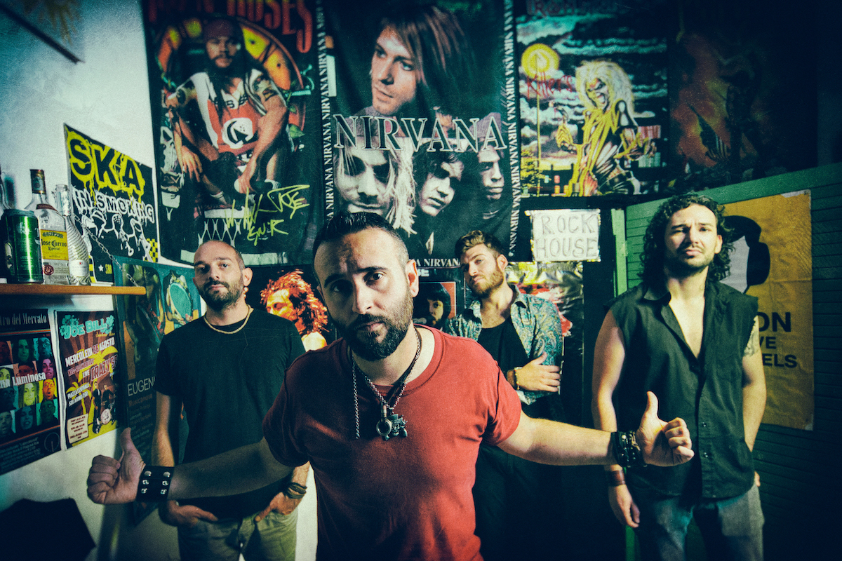

Short Bio:
When a band of Sicilian rockers, adepts of Mediterranean and Balkan music, decided to recreate it to their own recipe, the result was quite simply stunning.

With a Gypsy-Punk energy that would get village grandmothers off the bench and dancing, the six rascals of Giufà take us tumbling under the hot sun of the Balkans, the Maghreb or Syracuse with melodies inspired by both the Sicilian Tarantella and by Spanish or Afro-Cuban rumba.

A wildly playful music with lyrics full of imagery that deal with politics and more personal themes, but always with the same bandit humor.

On 2020 the new album "It's Everything Alright" is produced released by Escudero Records / Disques Office.

Line Up:
Danilo: Voice, Guitar
Andrea: Sax
Riccardo: Bass
Sergio: Bass, Producer
Salvo: Drums

Official Videoclips:
“It’s Everything Alright” : https://youtu.be/Dy9EGXQgSMU
“Propagangster” : https://youtu.be/7bnx7XK0Z6s
“Wonderful Fall ft. Rumba de Bodas” : https://youtu.be/4IxgOJk1IKg
“Live at Paléo Festival @ Nyon (France)” : https://youtu.be/h31fEwWsdiI
“Dalla Grecia alla Sicilia”: https://youtu.be/bPqbcXZV1c0
“I Re della Città ft. Municipale Balcanica”: https://youtu.be/aIq0UbuEedE

Web Contacts:
Web site: https://giufaband.com
Facebook: https://facebook.com/giufaband
Instagram: http://instagram.com/giufa_official/
YouTube: https://youtube.com/GiufaSR
Spotify: https://open.spotify.com/artist/37DJ1poDI05LulG0FYoSuG
Twitter: https://twitter.com/giufa_band

Discography:
2020 – CD @ It’s Everything Alright (Escudero Records / Disques Office)
2015 – CD @ Trinakristan (Escudero Records / Disques Office)
2013 – CD @ Ritmo Gitano

